|  |  |  |  |  |  |  |
| --- | --- | --- | --- | --- | --- | --- |
| **School of Computer Science & Software Engineering**  Bachelor of Computer Science (Digital Systems Security) | | | | | | |
|  | CSCI321- Project  User Manual | | | |  | |
|  | Group: SS18-4B | | | |  | |
|  | Hidir Ibrahim | 5920620 | | muhammad683@mymail.sim.edu.sg | |  |
|  | Nitisha Venkatachari | 5283048 | | vp001@mymail.sim.edu.sg | |  |
|  | Eustacia Lim You Yan | 5922173 | | yyelim001@mymail.sim.edu.sg | |  |
|  | | |  | | | |
|  | | | Supervisor: Dr Ta Nguyen Binh Duong | | | |
|  | | | Assessor: Prof Tan Kheng Teck | | | |

Table of Contents

Document Control 3

Roles 3

Record of Revision 3

Application Summary 4

Getting Started 4

Installation 4

*WampServer* 4

*Tesseract* 12

*OpenCV* 17

Starting the Program 19

*Manage Website Content* 19

*Manage Admins* 25

*Manage Critical Section* 30

*Authentication: Visual Cryptography* 32

## Document Control

Title: Secure Remote Authentication using Visual Cryptography

|  |  |  |  |
| --- | --- | --- | --- |
| **Owner** | **Current Version** | **Last Modified** | |
| Hidir Ibrahim  Nitisha Venkatachari  Eustacia Lim You Yan | 1.0 | **Date** | **Time** |
| 31/12/2018 | 1700 |

### Roles

|  |  |
| --- | --- |
| **Name** | **Role** |
| Hidir Ibrahim | Project Leader |
| Nitisha Venkatachari | Lead Designer |
| Eustacia Lim You Yan | Lead Developer |

### Record of Revision

|  |  |  |  |  |
| --- | --- | --- | --- | --- |
| **Revision Date** | **Description** | **Section Affected** | **Changes Made By** | **Version** |
| 31/12/2018 | Document Created | All | Everyone | 1.0 |
| 1/3/2019 | Modification of Document | All | Everyone | 1.1 |

## Application Summary

This user manual provides a walkthrough of the program and how each function works. This program provides a two-factor authentication using password as primary authentication and Visual Cryptography as the second authentication if the user required to access critical sections of the system.

## Getting Started

The following items should be present before running the program:

WampServer – A local server package for Windows, allowing you to install and host web applications that use Apache, PHP and MySQL.

Tesseract – An Optical Character Recognition (OCR) tool that recognize and “read” the text embedded in images.

PHPMailer – An opensource PHP libraries to send emails.

BulletProof – A single-class library to upload images in PHP with security.

Pytesseract 0.2.6 – Allow to access Tesseract OCR program through the web using Python.

OpenCv – A python library that supports image processing.

## Installation

### ***WampServer***

Step 1: Download WampServer

The newest installation version currently available can be downloaded from http://www.wampserver.com/en/#download-wrapper which should be installed on the computer.

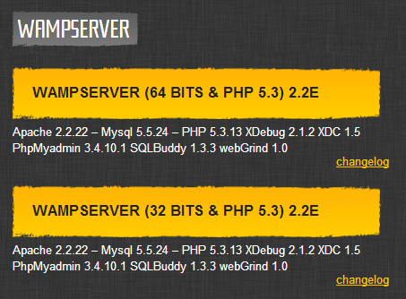

Step 2: Install WampServer

To start the installation process, you need to open the folder where you saved the file and double-click the installer file. A security warning window will open, asking if you are sure you want to run this file. Click **Run** to start the installation process.

Next you will see the Welcome to the WampServer setup Wizard screen. Click **Next** to continue the installation.

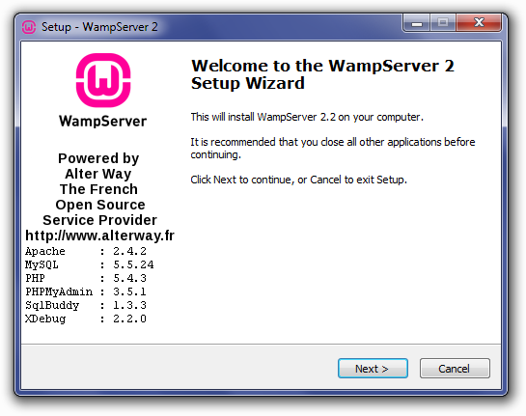

You will then be presented with is the License Agreement on the next screen. Read the agreement, check the radio button next to **I accept the agreement,** then click **Next** to continue the installation.

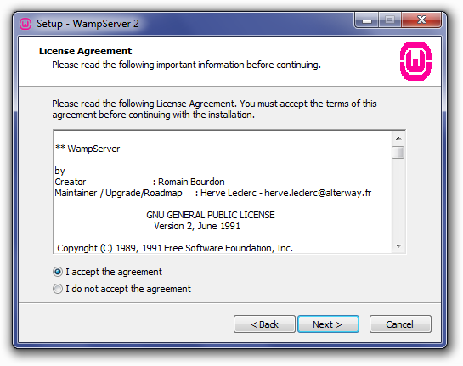

Next, you will see the Select Destination Location screen. Select where you want to install the WampServer. Click **Next** to continue.

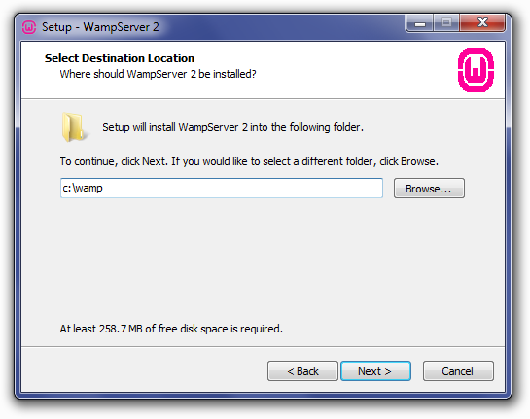

The next screen you are presented with is the Select Additional Tasks screen. You will be able to select whether you would like a Quick Launch icon added to the taskbar or a Desktop icon created once installation is complete. Mark your selections, then click **Next** to continue.

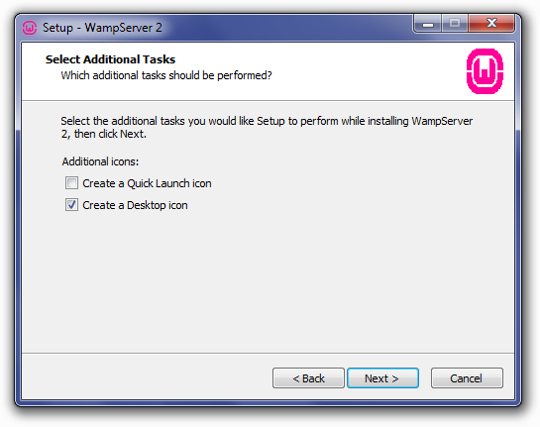

Next you will see the Ready to Install screen. You can review your setup choices and change any of them by clicking Back to the appropriate screen, if you choose to. Once you have reviewed your choice, click **Install** to continue.

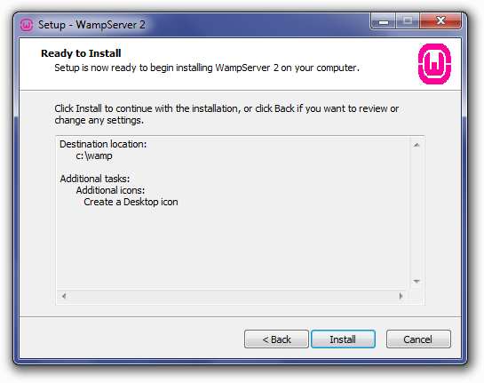

WampServer will begin extracting files to the location you selected.

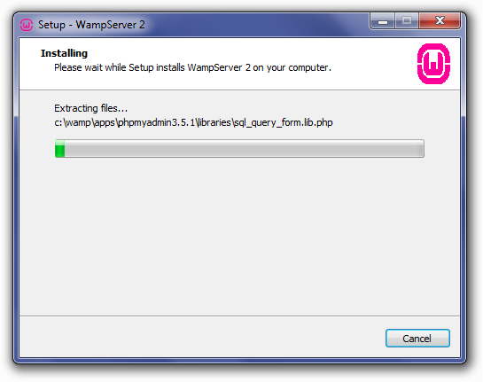

Once the files are extracted, you will be asked to select your default browser. WampServer defaults to Internet Explorer upon opening the local file browser window. If your default browser is not IE, then look in the following locations for the corresponding .exe file.

* **Opera**: C:\Program Files (x86)\Opera\opera.exe
* **Firefox**: C:\Program Files (x86)\Mozille Firefox\firefox.exe
* **Safari**: C:\Program Files (x86)\Safari\safari.exe
* **Chrome**: C:\Users\xxx\AppData\Local\Google\Chrome\Application\chrom.exe

Select your default browser’s exe file, then click **Open** to continue.

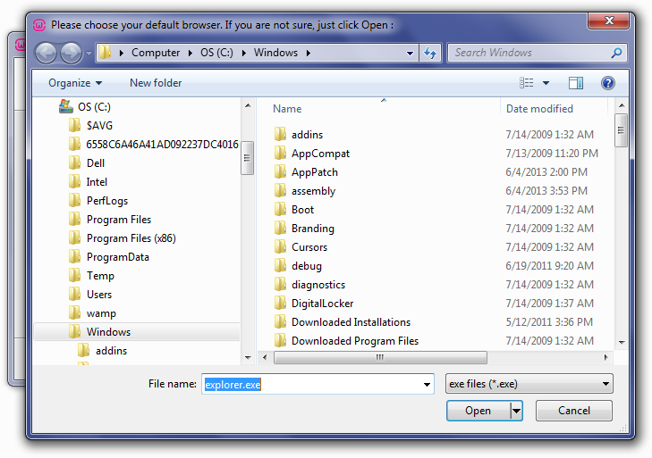

A Window Security Alert window will open, saying that Windows Firewall has blocked some features of the program. Check whether you want to allow Apache HTTP Server to communicate on a private or public network, then click **Allow Access**.

The Setup screen will appear next, showing you the status of the installation process.

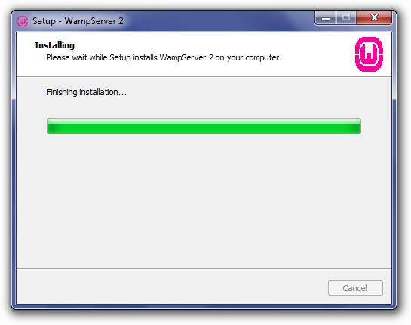

Once the progress bar is completed, the PHP Mail Parameters screen will appear. Leave the SMTP server as **localhost** and change the email address to one your choosing. Click **Next** to continue.

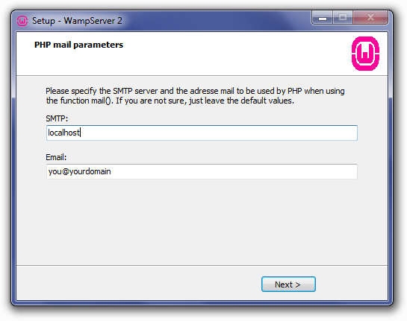

The Installation Complete screen will now appear. Check the **Launch WampServer Now** box, then click **Finish** to complete the installation.

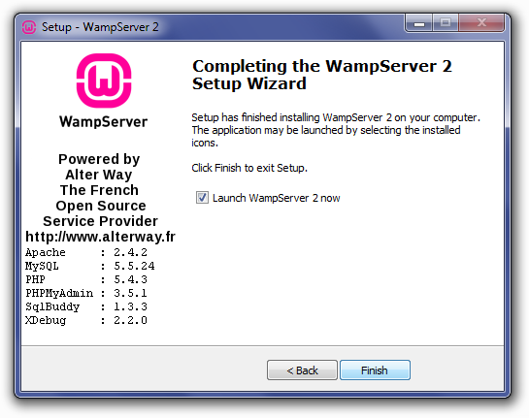

The WampServer icon should appear in the system tray on the right side of your taskbar. If the icon is green, then everything is working properly. If the icon is orange, then there are issues with one of the services. If the icon is red, then both Apache and MySQL services aren’t running. You will need to resolve those issues before continuing.

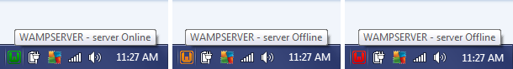

Step 3: Run WampServer

Once the installation process is completed, run your installation by going to <http://localhost/> in your browser. You should see the WampServer homepage displayed.

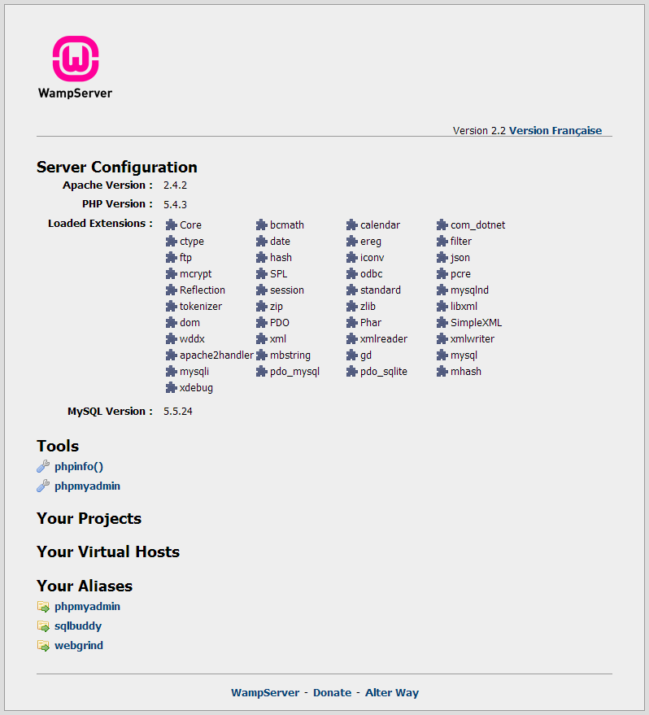

If the WampServer homepage does not display, you will want to check that your hosts file has **localhost mapped to 127.0.01**, and you aren’t running any other services on port 80, such as another local server (XAMPP, DesktopServer, etc), WebDAV, or Skype.

Step 4: Importing a MySQL Database with WampServer

Creating a database in WampServer is done via phpMyAdmin. You can access phpMyAdmin by entering <http://localhost/phpmyadmin/> in your web browser.

The main phpMyAdmin screen will appear. On the left is a list of databases that already exist: **information_schema, mysql**, and **performance_scheme**. Do not delete these, as they are necessary for WampServer and phpMyAdmin to run properly.

To import a database, click **Import** in the main navbar at the top.



On the importing screen, you will need to choose the .sql file to import from your computer, then click **Go.**

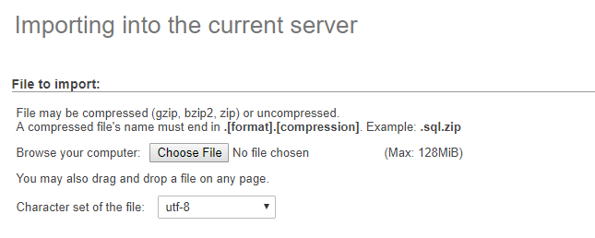

You will see a success message once the database has been imported, and the imported database will appear in the list on the left.

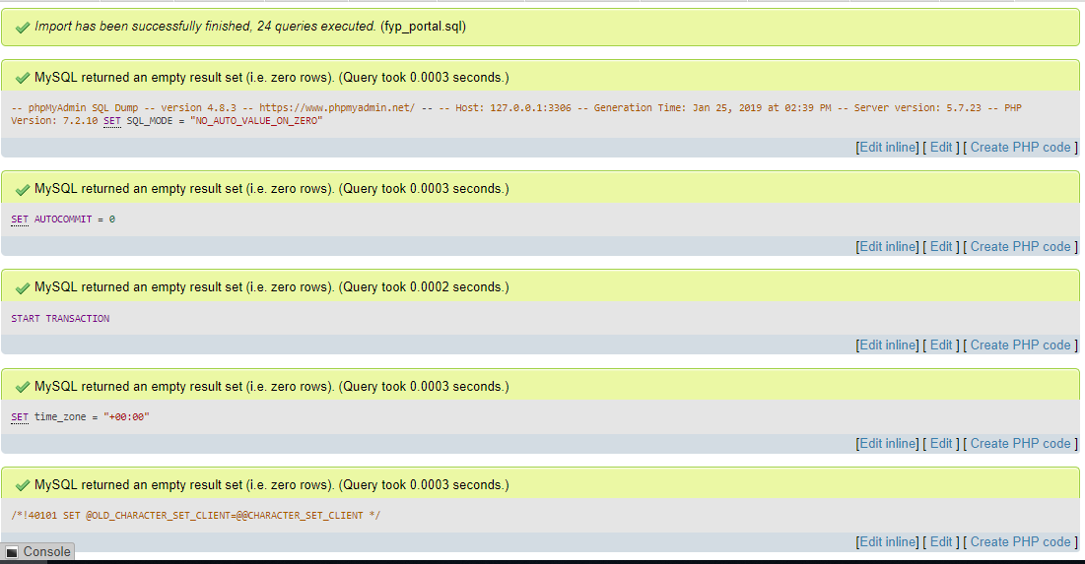

The default phpMyAdmin user, **root**, is automatically assigned to the database upon creation, and has no password.

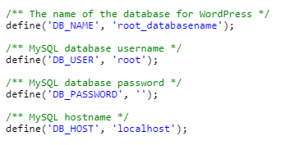

### ***Tesseract***

Step 1: Download Tesseract

The newest installation version currently available can be downloaded from https://github.com/tesseract-ocr/tesseract/wiki/Downloads which should be installed on the computer.

Step 2: Load Setup

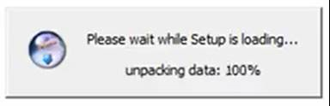

Step 3: Choose Language

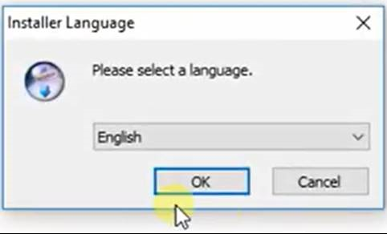

Step 4: Start Setup Wizard

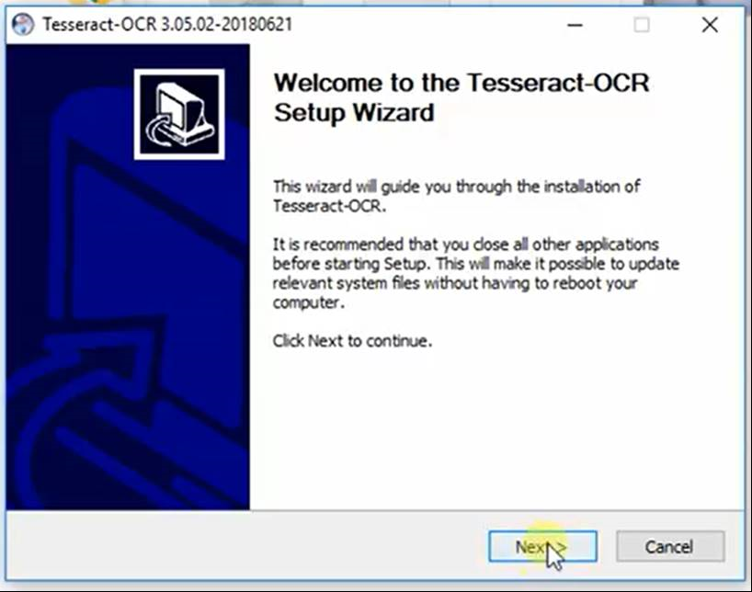

Step 5: Accept License Agreement

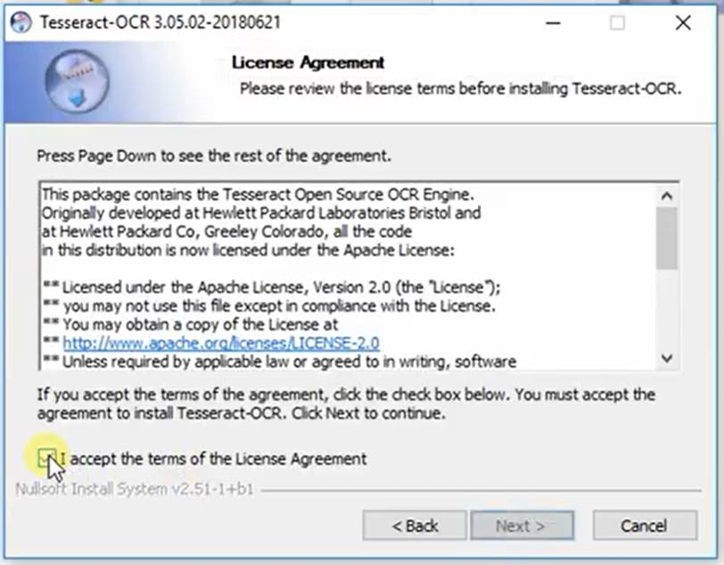

Step 6: Choose Users

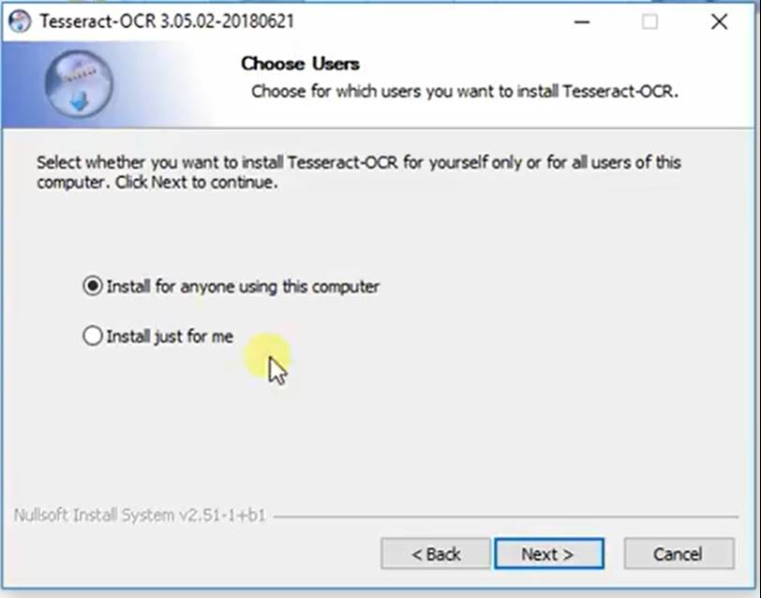

Step 7: Select Components

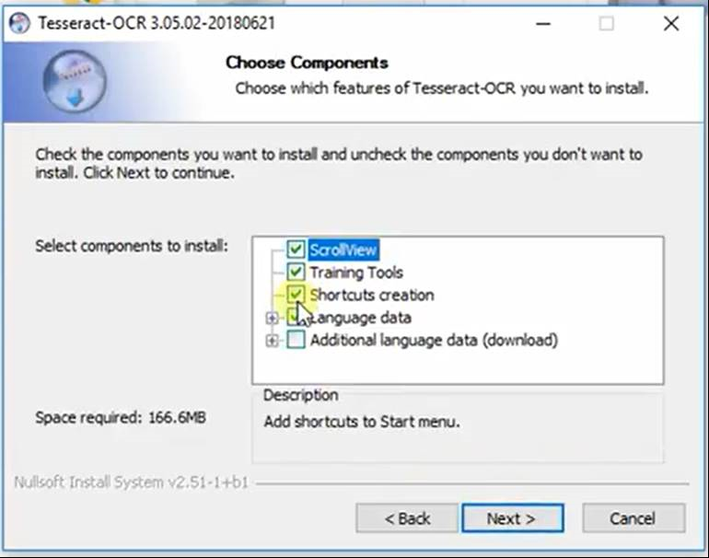

Step 8: Choose Install Location

Default location is usually C:\Program Files (x86) \ Tesseract-OCR

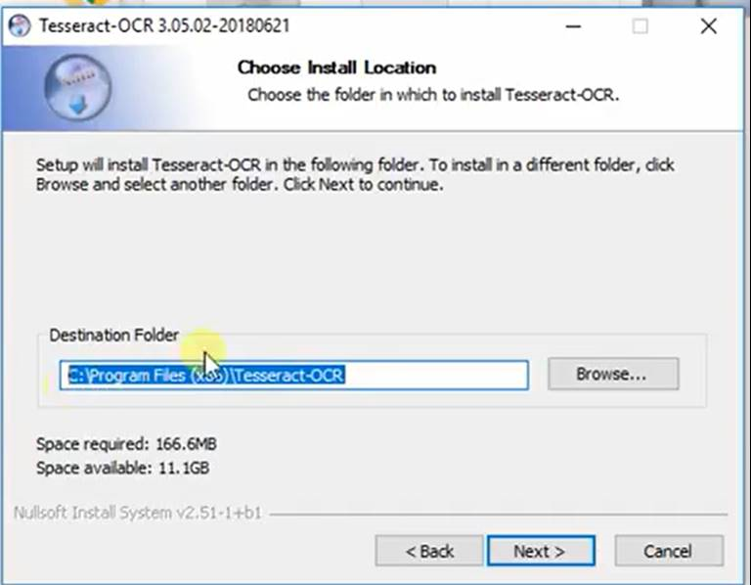

Step 9: Choose Start Menu Folder

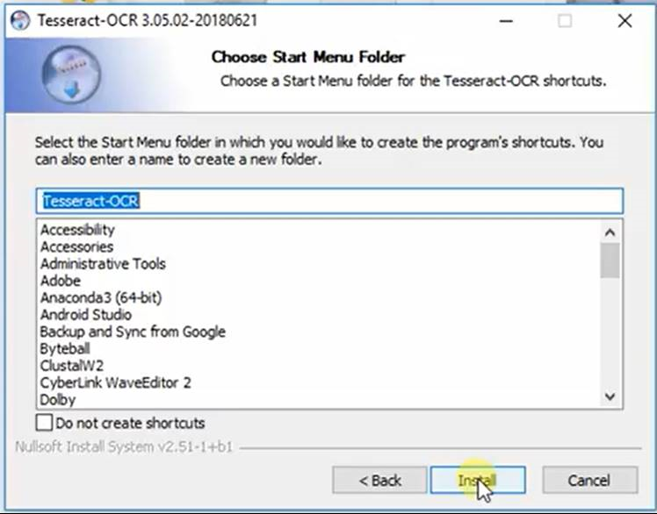

Step 10: Installation Complete

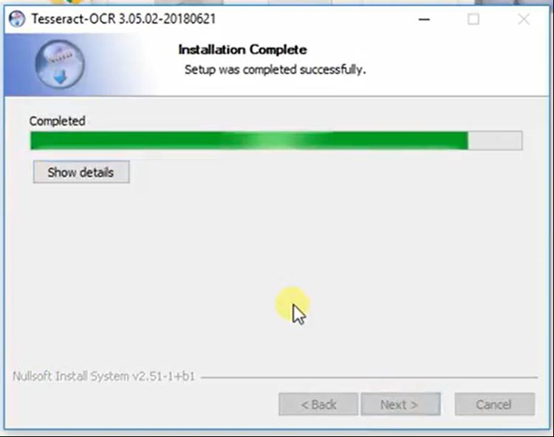

Step 11: Complete Setup Wizard

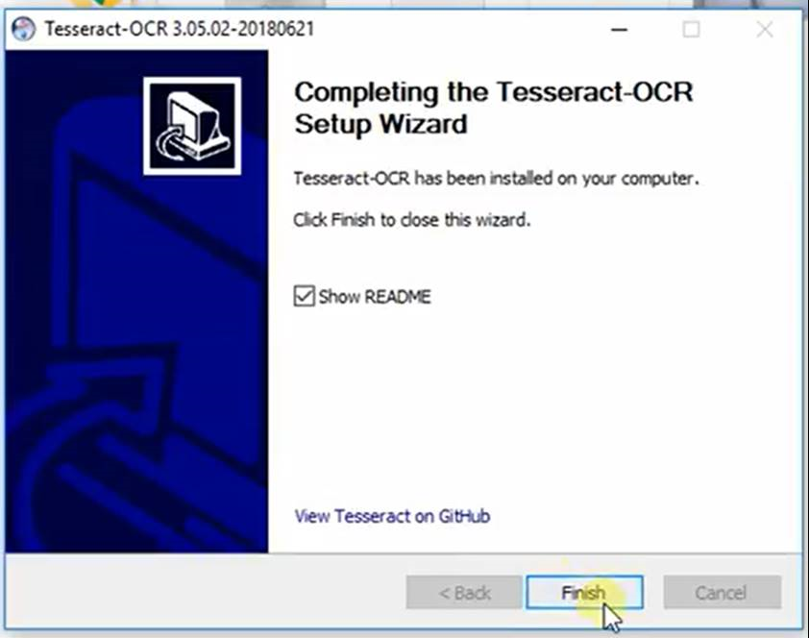

### ***OpenCV***

Step 1: Download OpenCV

The newest installation version currently available can be downloaded from <https://opencv.org/releases.html> which should be installed on the computer.

Step 2: Extract Contents

Default folder is usually in C:\Users\ (nameOfUser’sComputer) \Downloads\

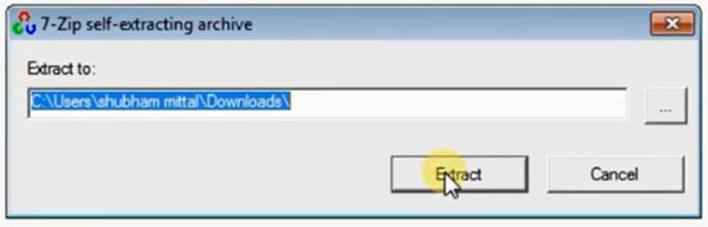

Step 1a (0% Extracted)

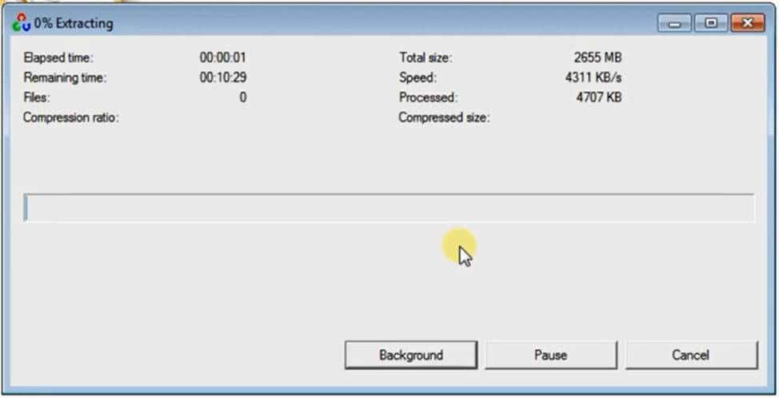

Step 1b (100% Extracted)

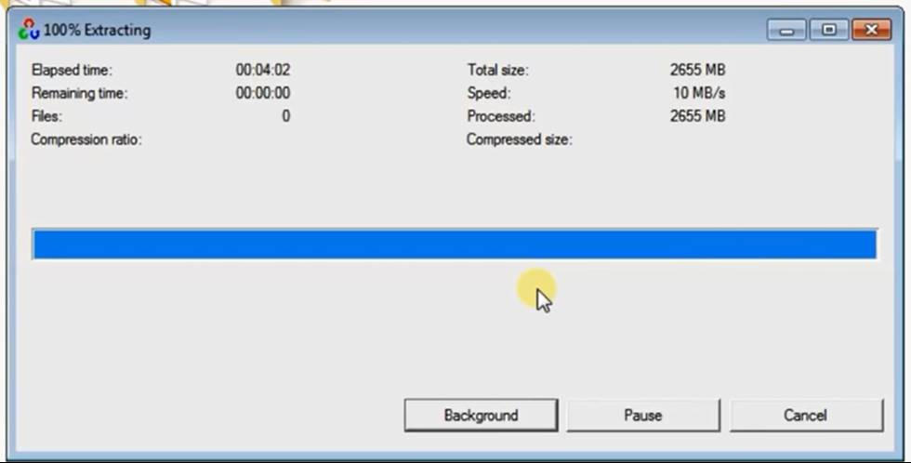

Step 2: Go to Python Shell

Version used in sample installation is Python 2.7.12.

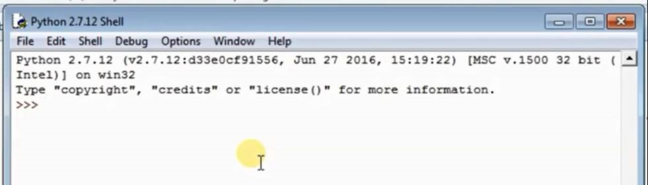

Step 3: Import cv2

This is to test and verify that the installation in successful.

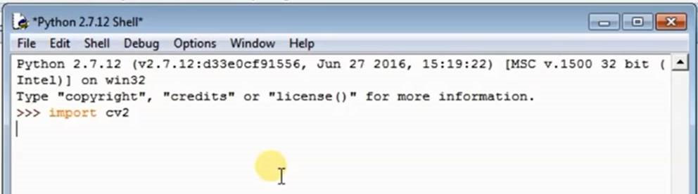

## **Starting the Program**

Run WampServer on the computer and open browser (e.g. Google Chrome, Firefox). In the browser, type in <http://127.0.0.1/> to run the localhost. Under Your Project, you can see that file *package* is included. Then run [http://127.0.0.1/cms_css_tesseract/](http://127.0.0.1/package/). The home page will be displayed.

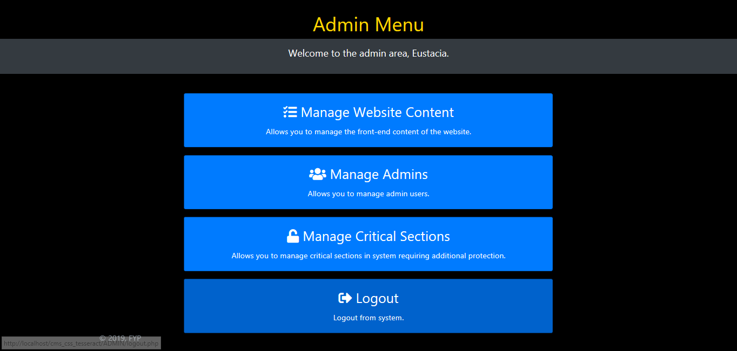

### ***Manage Website Content***

Add Subject

Step 1: Click on Add New Subject from the sidebar.

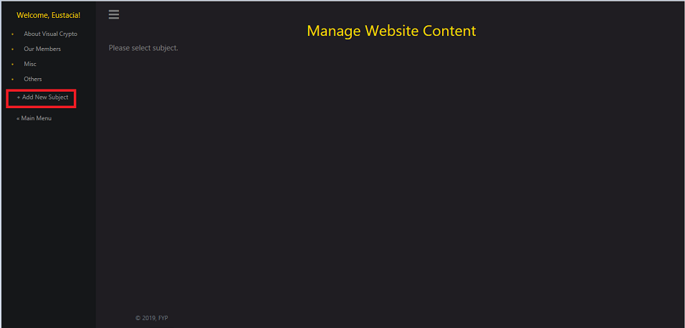

Step 2: Fill in the Menu Name, Position, Visibility Option and Content.

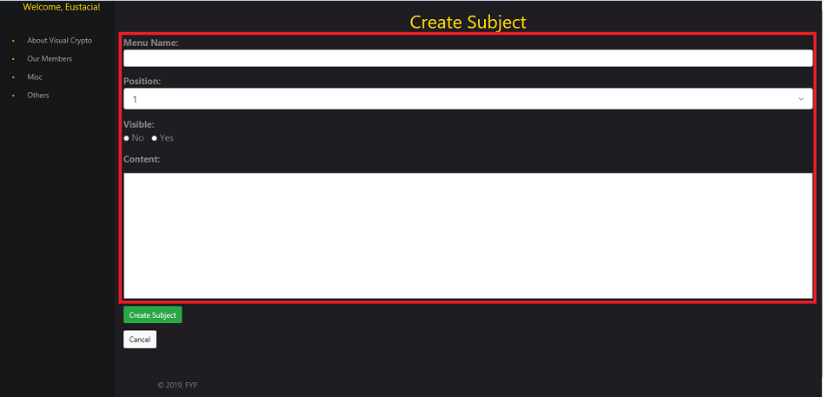

Step 3: Click on Create Subject button.

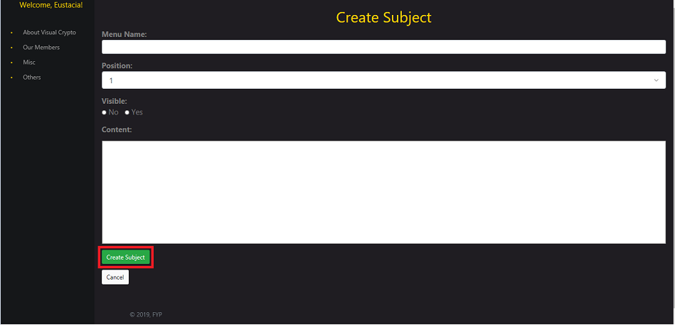

Edit Subject

Step 1: Click on the Edit Subject button.

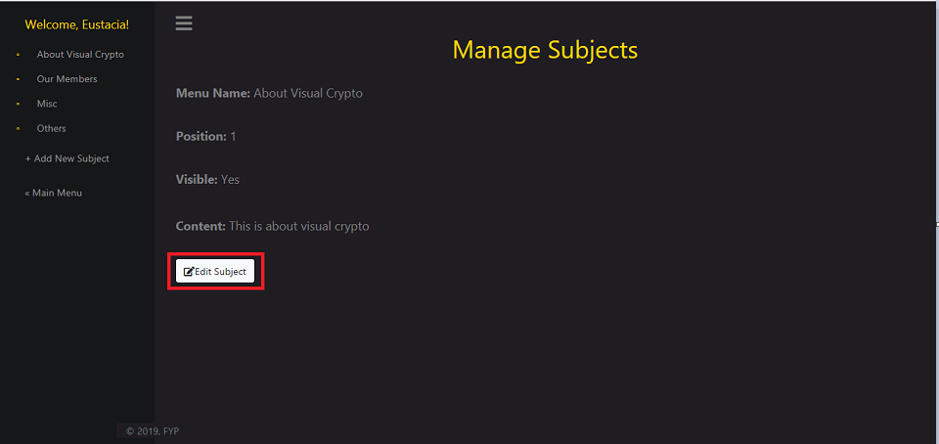

Step 2: Edit Menu Name, Position, Visibility or Content.

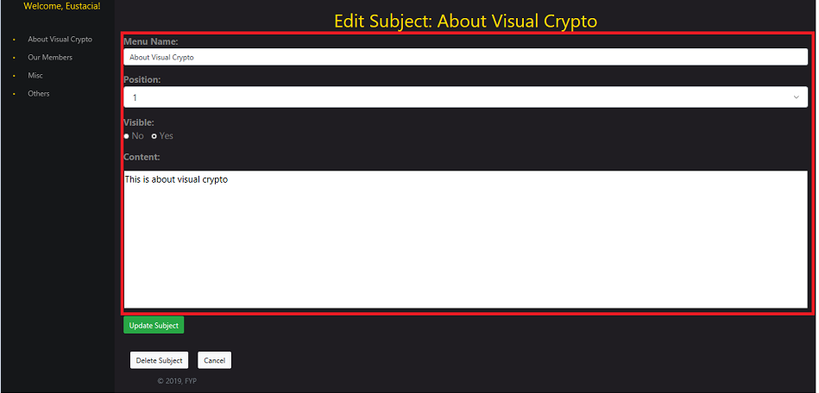

Step 3: Click on Update Subject button.

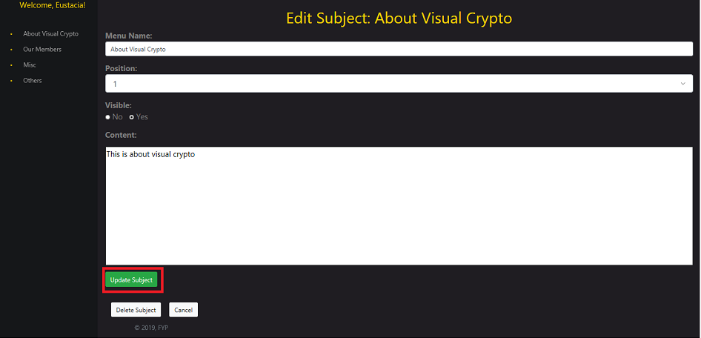

Delete Subject

Step 1: Click on the Edit Subject button.

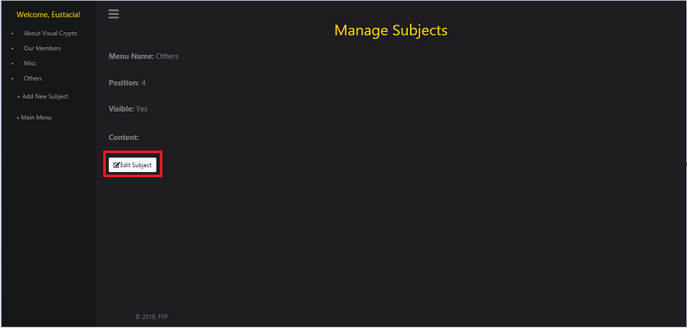

Step 2: Click on the Delete Subject button.

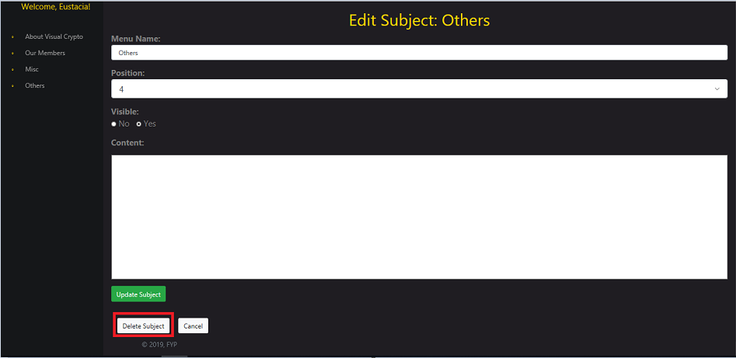

Step 3: Click OK for the prompted message.

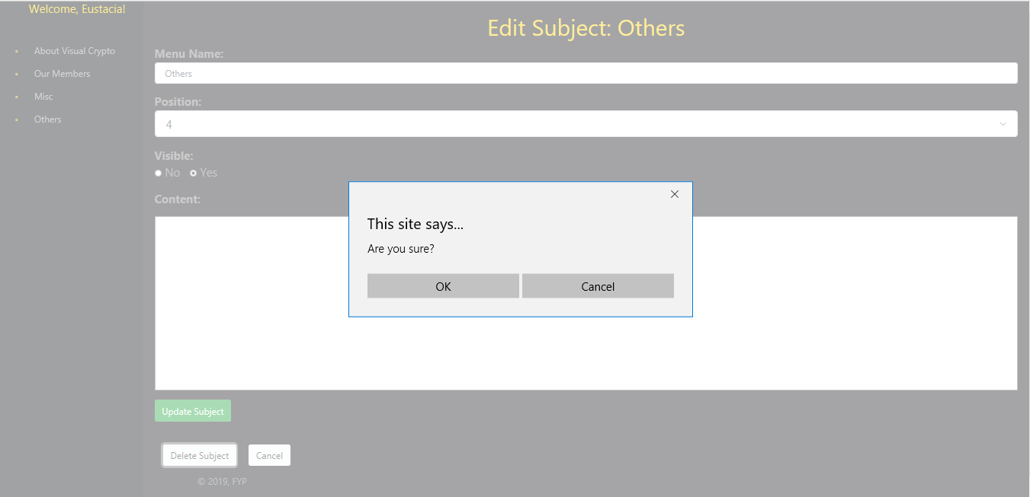

Step 4: The deleted subject will disappear from the sidebar menu.

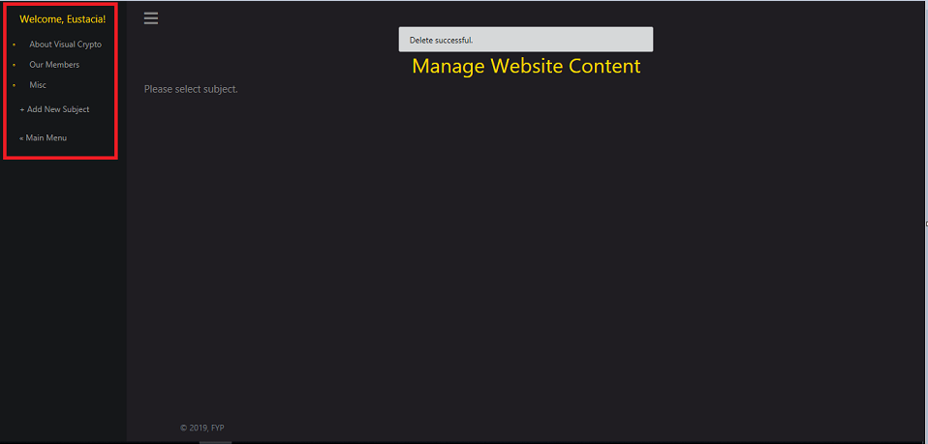

### ***Manage Admins***

Add Admin

Step 1: Click on Add button.

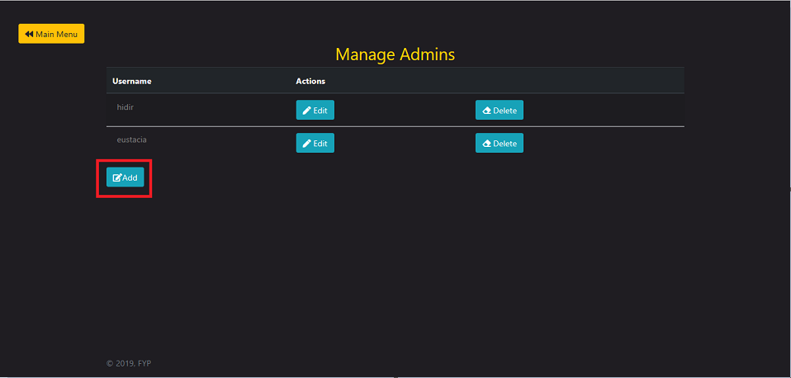

Step 2: Fill up the username, password, first email and second email to create new admin.

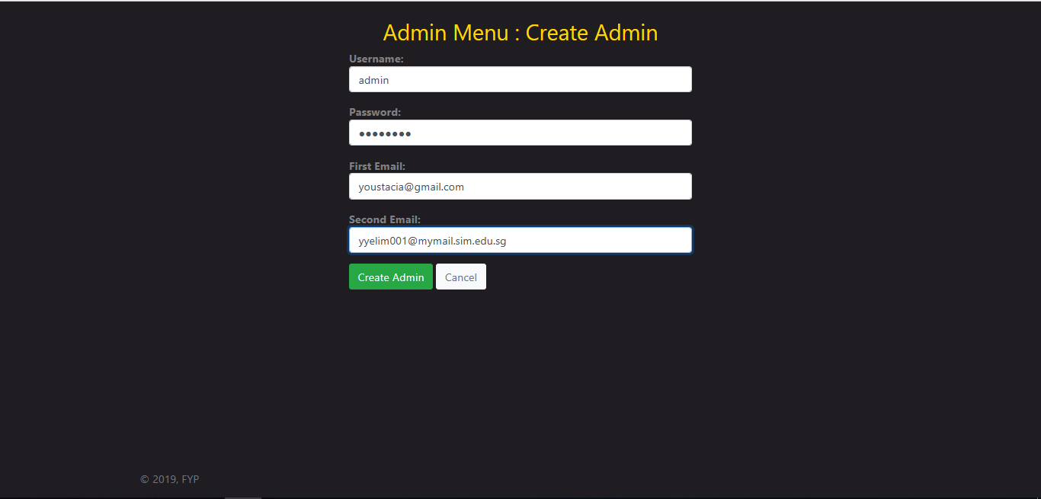

Step 3: Click on Create Admin button.

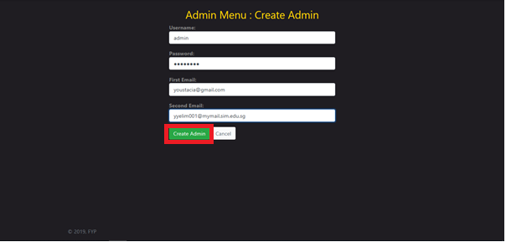

Step 4: The Manage Admins page will show that new admin has been added.

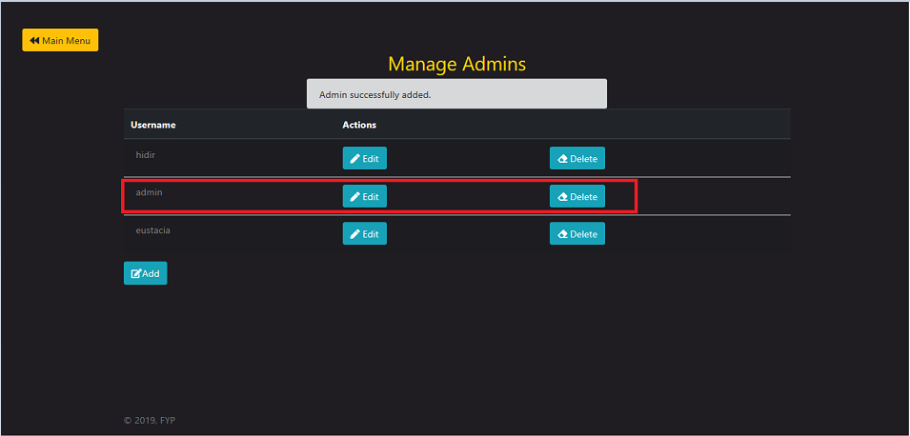

Edit Admin

Step 1: Click on Edit button.

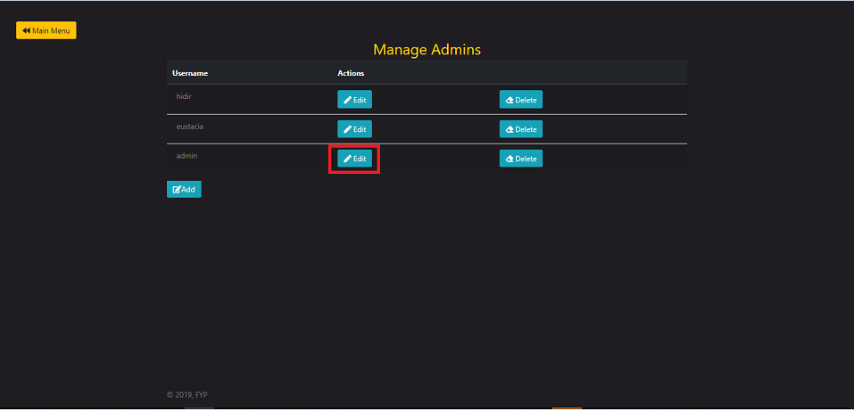

Step 2: Edit Username or Password.

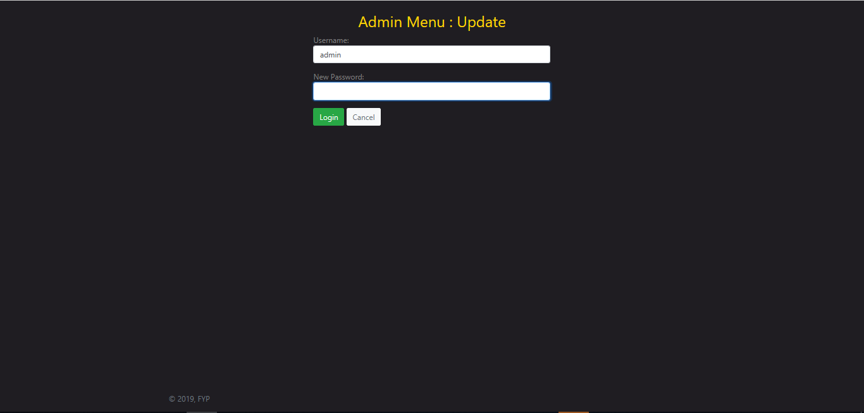

Step 3: Click on Login button to update the information of the admin.

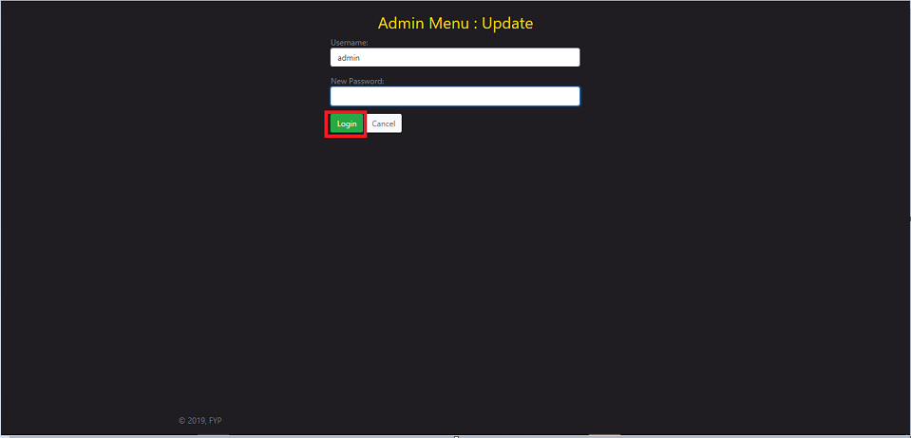

Delete Admin

Step 1: Click on Delete button.

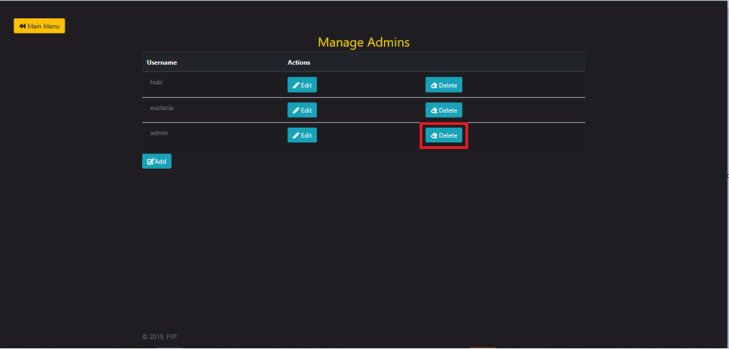

Step 2: Click OK for the prompted message.

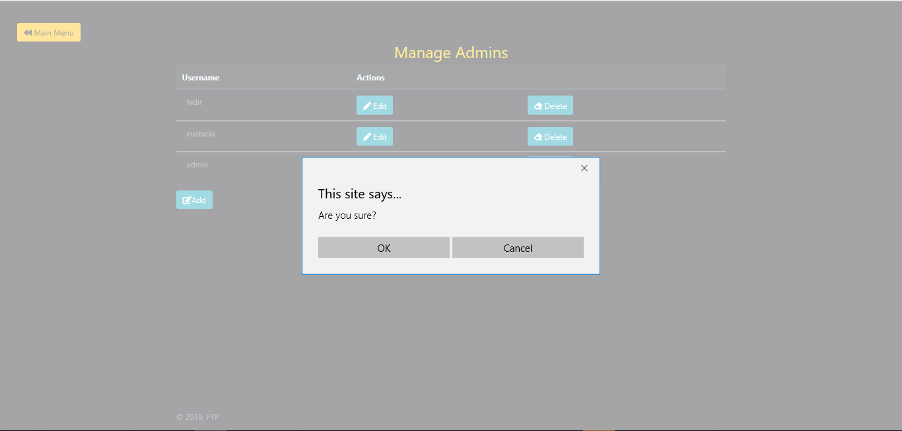

Step 3: The deleted admin will be removed.

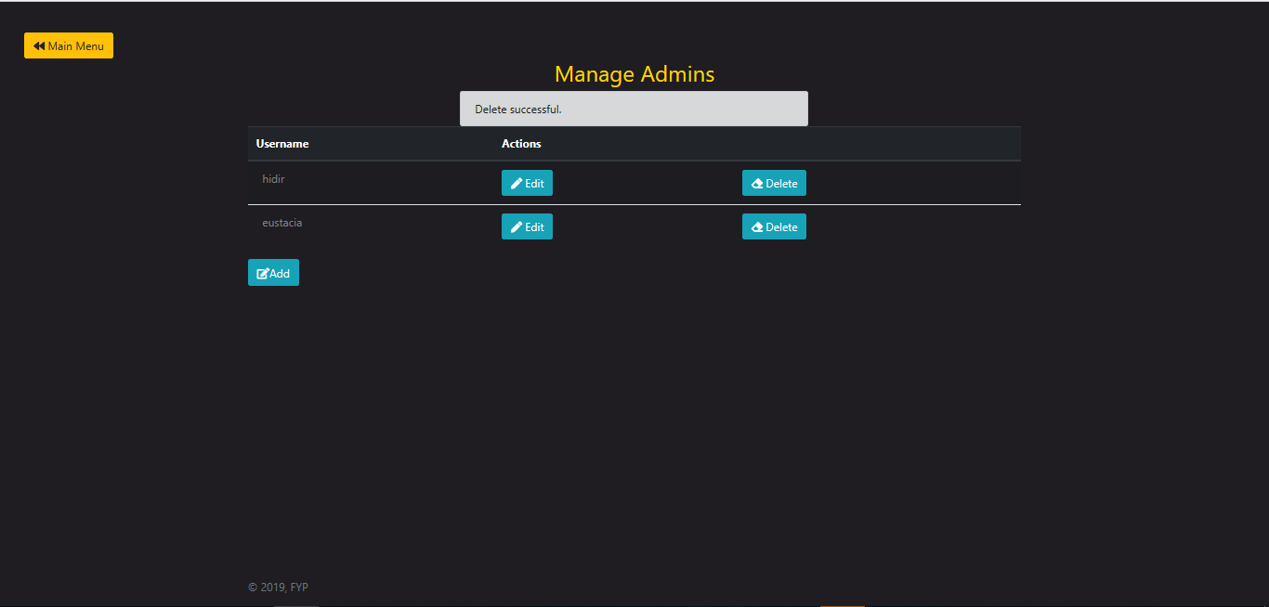

### ***Manage Critical Section***

Add Critical Section

Step 1: Add a page as Critical Section (e.g. manage_admins.php). Click on Add button.

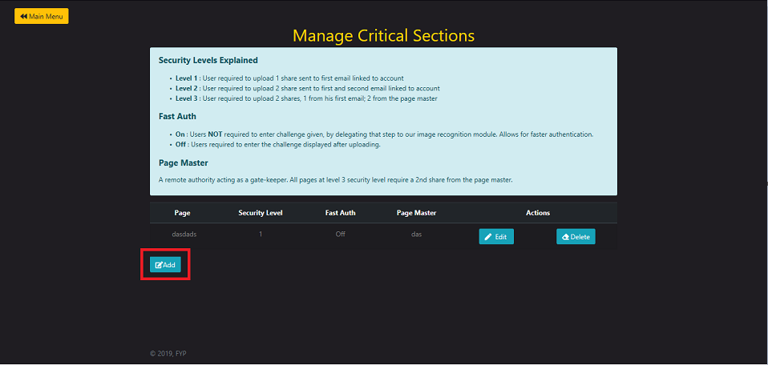

Step 2: Fill in the Page Name, Security Level, Fast Auth and Page Master.

**Security Level:**

*Level 1: User required to upload 1 share sent to first email linked to account.*

*Level 2: User required to upload 2 shares sent to first and second email linked to account.*

*Level 3: User required to upload 2 shares, 1 from his first email; 2 from the page master*

**Fast Auth:**

*On: User NOT required to enter the challenge give, by delegating that step to the image recognition module. Allows for faster authentication*

*Off: Users required to enter the challenge displayed after uploading.*

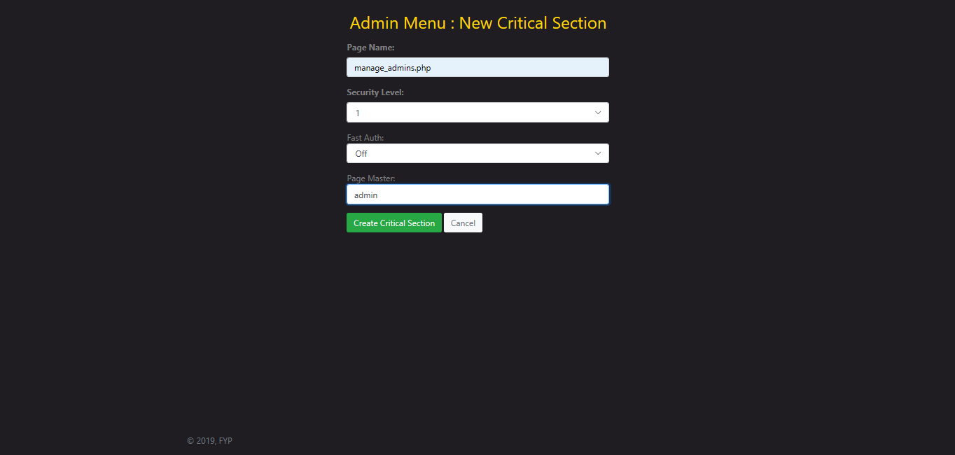

Step 3: The new critical section will be displayed as shown.

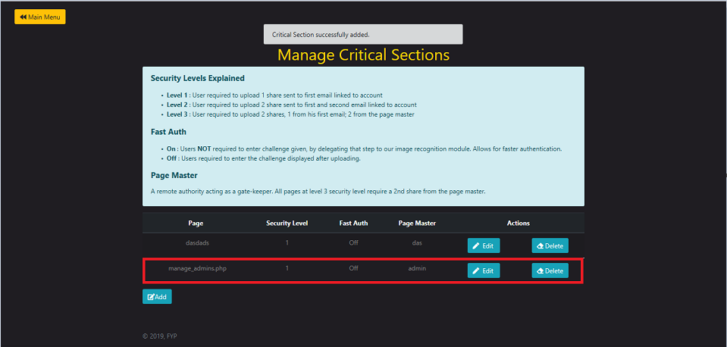

***Manage_admins.php will need further authentication to be able to access the information.***

***If we try to access manage admin again, it will show the image as shown below.***

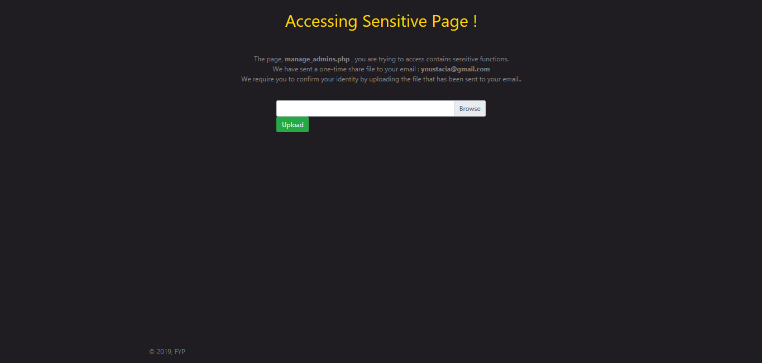

### ***Authentication: Visual Cryptography***

Step 1: If the existing admin is accessing a critical section of the program, the program will send an email to the admin to verify his identity.

Step 2: The existing admin will log into the email that the program had sent a one-time share file to the email.

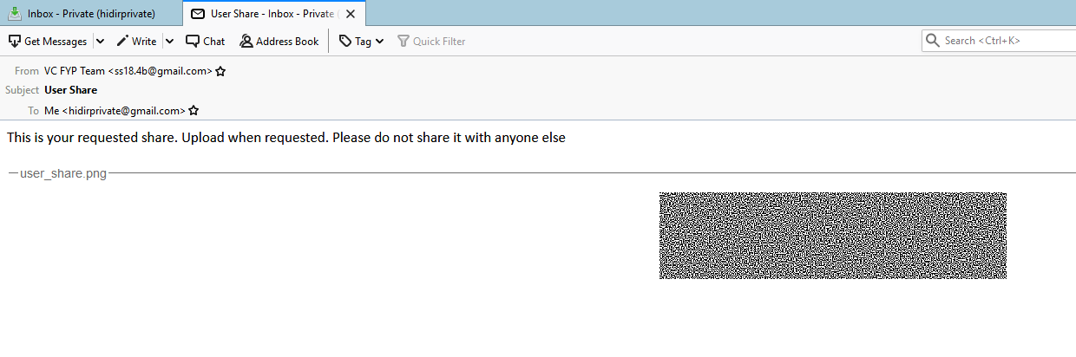

Step 3: The admin will upload his image share file from the email.

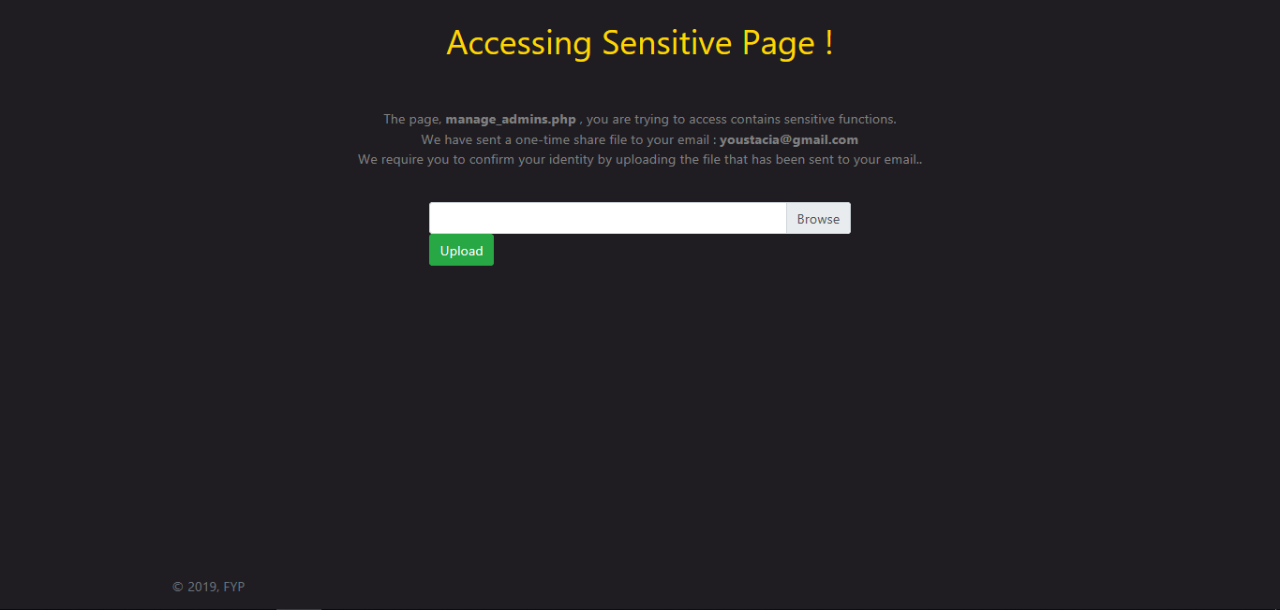

Step 4: If the uploaded shares is correct, the image will be readable if not the image will be unreadable.

**Successful Verification**

